**Create a custom docker image for nginx and deploy it using docker compose, where the volume bind mount should be at /var/opt/nginx location. Push the created custom docker image to your docker-hub.**

**Step 01:** Creating Directories

**Step 02:** Creating Dockerfile

**Step 03:** Creating docker compose file

**Step 4:** Building Custom Docker Image

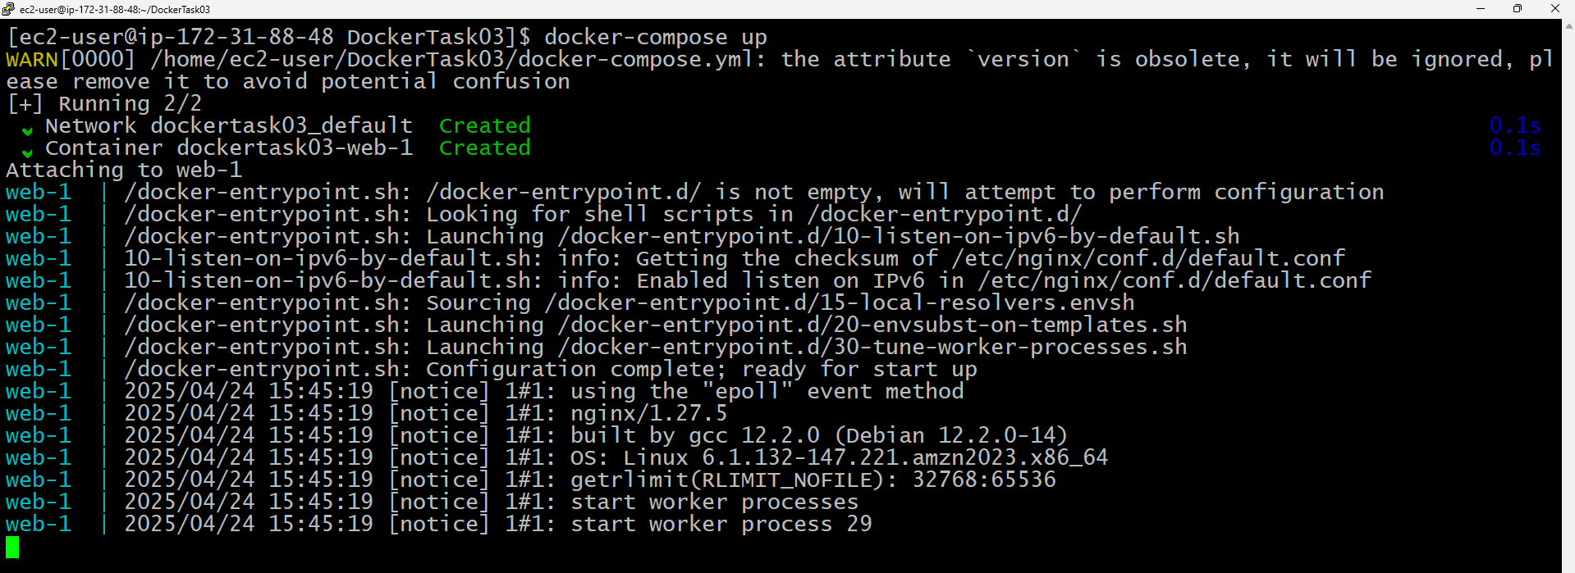

**Step 6:** Pushing Custom Image to Docker Hub

**Step 07:** The docker image has been pushed into my Repo

